# Practice sheet A

**Table: Employee**

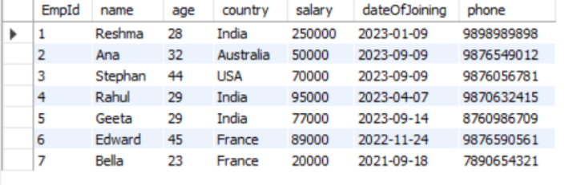

1. Write an SQL statement to display specific columns such as names and salaries for all Employees
2. Write a SQL query to locate an employee who lives in ‘India'. Return the employee’s name and country.
3. Write an SQL statement to return the name of an employee whose salary is more than 40000.
4. Write a SQL statement to return the name of an employee whose salary is between 50000 and 80000.
5. Write a SQL query to find the employee whose ages are higher than or equal to 30. Order the result by age in descending.
6. Write a query to display the names of employees in the order of their joining date.
7. Write a query to count the number of employees.
8. Write a query to display the name and salary of an employee who either lives in France or Australia.
9. Write a query to delete the records of Ana.
10. Write an SQL query to find the lowest salary of an employee
11. Write an SQL query to find the highest salary of an employee
12. Write a query to add an email column in the existing employee table.
13. Write a query to update the age of an employee to 55 and salary to 90000 where id is 4.
14. Write a query to rename a column country to address
15. Write a query to delete the age column.
16. Create a table named person with fields id, name, city, age, email, country using the following constraints.

i) The field id should be a primary key

ii) Name field cannot be null

iii) city field cannot be null and for default value use “Delhi”

iv) Age should be greater than 18

v) email should be unique and cannot be null

vi) country field cannot be null and for default use “India”